Google Pay-Inspired Expense Sharing System
Project Code
google_pay.ipynb: Jupyter notebook with concept development and iterative refinement of the ExpenseSharing class logic.
Final Python script with the ExpenseSharing class and interactive input for friends, expenses, and optimized settlements.
Methodology
Class: ExpenseSharing
- __init__(self, friends): Stores self.friends and initializes self.balances = {friend: 0 for friend in friends}
- add_expense(self, payer, amount, participants):
  - split_amount = amount / len(participants)
  - For each participant in participants, subtracts split_amount from self.balances[participant]
  - Adds full amount to self.balances[payer]
- calculate_settlements(self):
  - Creates creditors list for positive balances and debtors list for negative balances (absolute value)
  - Prints --- Final Balances --- and the self.balances dictionary
  - Prints --- Optimized Settlements --- and, in a loop, pops one debtor and one creditor
  - Computes payment = min(debt_amount, credit_amount) and prints **{debtor} owes {creditor}: ₹{payment:.2f}**
  - If remaining debt or credit exists, appends back with updated amount
Data Processing Steps
Data Collection:
Friends list taken either as fixed Python list or from input:
- raw_friends = input("Enter the names of friends, separated by commas: ")
- friends_list = [f.strip() for f in raw_friends.split(",")]
For each expense:
- payer = input("\nWho paid? (or type 'done' to calculate): ").strip()
- If payer.lower() == "done", exit the loop
- Check if payer not in friends_list: print("Error: Name not in the original friends list.") and continue
- amount = float(input(f"How much did {payer} pay? ₹"))
- raw_parts = input("Who shared this expense? (comma separated): ")
- participants = [p.strip() for p in raw_parts.split(",")]
- Call expense_sharing.add_expense(payer, amount, participants)
Preprocessing:
- Names trimmed using .strip()
- Comma-separated lists split and individually stripped
- Amount converted to float with try-except error handling
- Payer validated against original friends list
- All balances initialized at zero and updated sequentially
Results and Sample Output
After exiting input loop, call expense_sharing.calculate_settlements()
Example Final Balances:

Table 1: Final Balances from Test Case
Example Optimized Settlements:
Eve owes Bob: ₹16.67
Carol owes Bob: ₹183.33
Carol owes Alice: ₹100.00
Settlement complete.
Interpretation:
- Positive balance = creditor (should receive money)
- Negative balance = debtor (should pay money)
- Zero balance = settled up
- Three transfers settle all debts efficiently
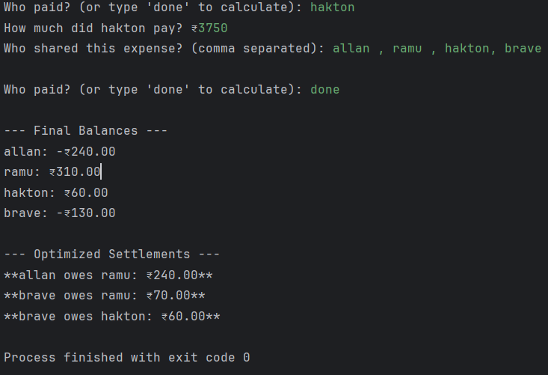
Fairness Logic
Equal Split Method:
- For amount $A$ shared by $n$ participants: each share = $A/n$
- Each person's share subtracted from their balance, full amount added to payer's balance
- Sum of all balances always equals zero, ensuring conservation of money
Handling Uneven Contributions:
- Heavy payers develop positive balances
- Light payers develop negative balances
- Settlement algorithm routes money from debtors to creditors
- Result: fair reimbursement regardless of initial payment distribution
Edge Cases:
- Invalid names: System validates payer exists in original friends list; prints error and continues without updating balances
- Floating-point precision: Uses 0.01 threshold when checking if balance is zero to avoid rounding errors
- Refunds: Encoded as additional transactions where person pays back group
- Corrections: Added as balancing transactions to fix accounting errors
Optimized Settlement Algorithm
- Separate people into creditors (positive balance) and debtors (negative balance)
- While both lists have members:
Match first debtor with first creditor
Calculate payment = min(debt_amount, credit_amount)
Record transfer from debtor to creditor
Update remaining amounts
Remove settled parties from lists
- Repeat until no debtors or creditors remain
Greedy approach minimizes number of transfers compared to naive methods.
System Architecture
Code Structure:
- ExpenseSharing class encapsulates all logic
- add_expense() handles transaction recording
- calculate_settlements() handles balance computation and settlement output
- Error handling with try-except for invalid amounts
- Input validation for friend names
Data Flow:
User Input (payer, amount, participants) → add_expense() updates balances → Next transaction → ... → calculate_settlements() prints results

